HCS

$ClusterNetworkName = "Cluster Network 1"

$IPResourceName = "RGIHCSAG_10.62.190.154"

$ILBIP = "10.62.190.154"

[int]$ProbePort = 55555

Import-Module FailoverClusters

Get-ClusterResource $IPResourceName | Set-ClusterParameter -Multiple @{"Address"="$ILBIP";"ProbePort"=$ProbePort;"SubnetMask"="255.255.255.0";"Network"="$ClusterNetworkName";"EnableDhcp"=0}

Get-ClusterResource $IPResourceName | Get-ClusterParameter

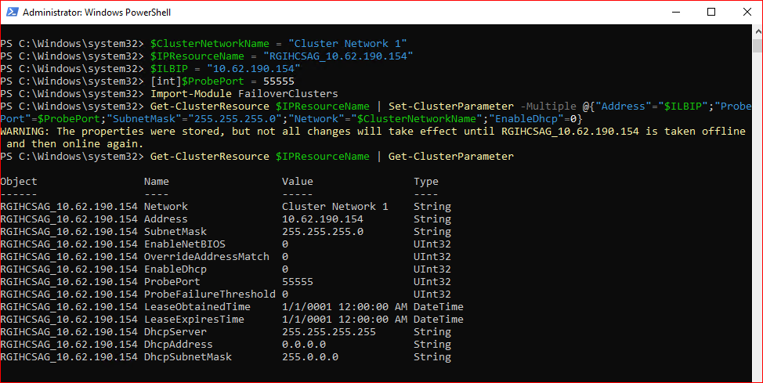

$ClusterNetworkName = "Cluster Network 2"

$IPResourceName = "RGIHCSAG_10.62.174.70"

$ILBIP = "10.62.174.70"

[int]$ProbePort = 55555

Import-Module FailoverClusters

Get-ClusterResource $IPResourceName | Set-ClusterParameter -Multiple @{"Address"="$ILBIP";"ProbePort"=$ProbePort;"SubnetMask"="255.255.255.0";"Network"="$ClusterNetworkName";"EnableDhcp"=0}

Get-ClusterResource $IPResourceName | Get-ClusterParameter

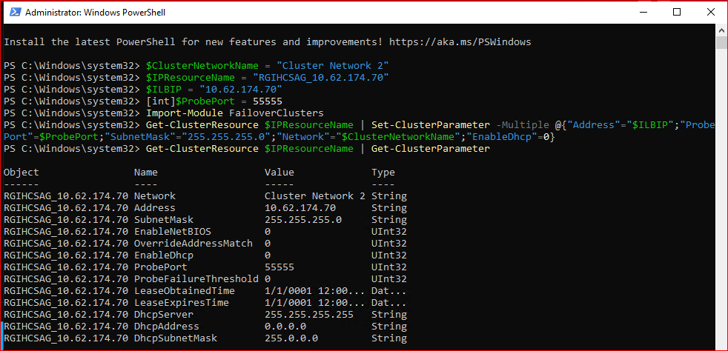

MPLUS

$ClusterNetworkName = "Cluster Network 1"

$IPResourceName = "RGIMPLUSAG_10.62.190.155"

$ILBIP = "10.62.190.155"

[int]$ProbePort =56666

Import-Module FailoverClusters

Get-ClusterResource $IPResourceName | Set-ClusterParameter -Multiple @{"Address"="$ILBIP";"ProbePort"=$ProbePort;"SubnetMask"="255.255.255.0";"Network"="$ClusterNetworkName";"EnableDhcp"=0}

Get-ClusterResource $IPResourceName | Get-ClusterParameter

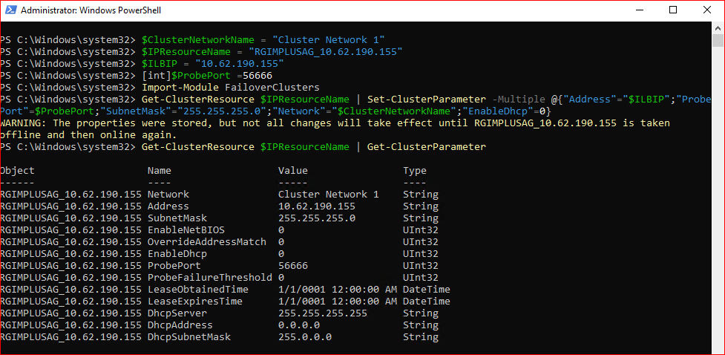

$ClusterNetworkName = "Cluster Network 2"

$IPResourceName = "RGIMPLUSAG_10.62.174.71"

$ILBIP = "10.62.174.71"

[int]$ProbePort = 56666

Import-Module FailoverClusters

Get-ClusterResource $IPResourceName | Set-ClusterParameter -Multiple @{"Address"="$ILBIP";"ProbePort"=$ProbePort;"SubnetMask"="255.255.255.0";"Network"="$ClusterNetworkName";"EnableDhcp"=0}

Get-ClusterResource $IPResourceName | Get-ClusterParameter

